DEVELOPMENT OF AUTOMATED TELLER MACHINE (ATM)

# ABSTRACT

This project focuses on deposit ,withdrawal and transfer of amount from the banks. To deposit or withdrawal amount from the banks manually is a time consuming process. To make this manual process fast this proposed system Automated Teller Machine (ATM) System has been designed. This proposed system deals with all transactions of actual ATM centres like login to customer account according to his pin number given, checking balance amount of savings account as well as current account. Also the account holder can deposit or withdraw amount from his current account or savings account respectively from any location. There will be no need of any human power to maintain the accounts. Since the all mathematical operation are done using program so it is error free and fast. The source independent java programming language is used to develop the system. Microsoft Access is used for storing all data or records.

Contents

ABSTRACT 1

1.0 INTRODUCTION 3

1.1 PROBLEM STATEMENT 4

TIME CONSUMING 4

PORTABLE AND 24/7 ACCESS TO THE BANK 4

1.2 PROPOSED SOLUTION 4

1.3 SCOPE 4

1.4 OBJECTIVES: 4

1.5 SYSTEM REQUIREMENTS 5

2.0 SYSTEM ANALYSIS 6

Disadvantages: 6

2.1Feasibility study: 6

2.1.1 Technical feasibility: 6

2.1.2 Social feasibility: 6

2.1.3 Economic feasibility: 6

2.1.4 Operation feasibility: 6

2.2 DESIGN OF NEW PROPOSED SYSTEM (ATM): 7

Advantages: 7

2.3 Objects in the class ATM 7

2.4 Objects in the class User 7

2.5 Objects in the class Transaction 7

2.6 Objects in the class Account 8

2.7 DATA FLOW DIAGRAM 8

2.8 Images from testing the codes 10

3.0 CONCLUSION 13

4.0 REFERENCES 14

## 1.0 INTRODUCTION

Automated Teller Machine enables the clients of a bank to have access to their account without going to the bank. This is achieved only by development the application using online concepts. When the product is implemented, the user who uses this product will be able to see all the information and services provided by the ATM, when he enters the necessary option and arguments. The product also provides services like request for cheques, deposit cash and other advanced requirement of the user. The data is stored in the database and is retrieved whenever necessary. The implementation needs ATM machine hardware to operate or similar simulated conditions can also be used to successfully use the developed product.

To develop this ATM system the entire operation has been divided into the following step:

1. Verification process

2. Language, service and account selection

3. Banking services

4. Transactions

5. Special services

The program is designed in such a way that the user has to card and pin number. Once verified, he is provided a menu and he/she had to enter the option provided in the menu. For example, when the user wants to view the list of payment history than he/she had to enter the option for payment history provided in the main menu. When the option is entered alone with the respective argument, then the payment history is displayed on the screen. The user also must be given option to browse through the pages like previous page, next page, etc. The user may experience a delay in retrieving or viewing the data, when there are many users logged on to the same bank branch system.

## PROBLEM STATEMENT

### TIME CONSUMING

Manual depositing and withdrawal of amount is time consuming since it takes longer hours to join a queue at the bank to deposit/ withdraw money and perform other transactions. Using ATM machine by customers are faster to perform bank transaction.

### PORTABLE AND 24/7 ACCESS TO THE BANK

Banks in Ghana averagely work within 8 – 9 hours in a day, this give customers less time to access the bank but with the introduction of ATM, customers can access the bank 24/7 even during the weekend to perform certain transactions.

## 

## 1.2 PROPOSED SOLUTION

The system customer transactions, satisfies the requirements of the existing system in full-fledged manner. Through this system, customer can make fast transactions and view the last transactions easily.

## 1.3 SCOPE

It can be implemented in ATM machine by owner of bank or in charge of branch.

It is easy to learn the task.

## 1.4 OBJECTIVES:

The main objective is to speed up the transactions done by customers. No manual transactions needed generally. The second objective is to save the time which is very important now-a-days. It will include other objectives such as:

* To render accurate services to customer.
* The reduction of fraudulent activities
* To achieve speedy processing of customer data
* To reduce error processing, the guarantee of increase security

## 1.5 SYSTEM REQUIREMENTS

Hardware Requirements:

* Processor :- Intel Pentium 4 or Later or Compatible
* Hard Disk :- 410GB or more
* RAM :- 1GB or more
* Printer :- Any
* Monitor :- SVGA Colour Monitor (Touch Screen or Simple)
* Pointing Device :- Touch Pad or Keys

Software Requirements:

* Operating System :- Microsoft Windows XP or Later or Equivalent
* Java jdk-15.0
* Eclipse installer/ NetBeans

# 2.0 SYSTEM ANALYSIS

Study of current/Existing system: In the manual system, firstly the bank manager and its staff have to manage information regarding the accounts and transaction of all the customers manually. Doing this manual transaction was really tedious job.

Secondly information regarding accounts and transactions of customers were to be maintained. This process is time consuming and it requires a great manual effort.

### Disadvantages:

* More time is consumed.
* More hard work to maintain all records.
* Bulk of paper is to be searched for a single search.

## 2.1Feasibility study:

### 2.1.1 Technical feasibility:

It provides comprehensive function to make it user friendly. The data entry and report generation is also made easy. Backup and restore of the database facility are also provided. It also provides easy retrieval of data. The machine configuration also supports this software.

### 2.1.2 Social feasibility:

As this system is user friendly and flexible some problems will also be solved which employee may be facing when using existing system. So we can say that system is socially feasible.

### 2.1.3 Economic feasibility:

The cost of converting from manual system to new automatic computerized system is not probably more. For construction of the new system, the rooms and its facilities are available so it does not require any extra resource, only the software requirement is there.

### 2.1.4 Operation feasibility:

Since the system is being in user friendly way, the new customers within a few time can master it.

## 2.2 DESIGN OF NEW PROPOSED SYSTEM (ATM):

This system provides paperless maintenance. Initially a cashier or a clerk can be appointed to do all the transaction and update and maintain records. In the new system the customer himself can do all the transaction and the computerized system automatically updates and maintains the records.

### Advantages:

* Less effort to complete transaction.
* Less time required.
* No need to maintain the bulk of papers

## 2.3 Objects in the class ATM

|  |  |
| --- | --- |
| Bank theBank | Bank name |
| User aUser | Name of account user |
| newAccount | New Account of the user |
| User authUser | Authorise user |
| pin | The unique pin of the user |
| fromAcct | Account from which the transaction is be perform |
| toAcct | Account to which the transaction is done |
| acctBal | Account Balance |

## 2.4 Objects in the class User

|  |  |
| --- | --- |
| this.uuid | Unique universal ID of the user |
| this.firstName | User first name |
| this.lastName | Last name of the user |

## 2.5 Objects in the class Transaction

|  |  |
| --- | --- |
| this.amount | Amount for the transaction |
| this.inAccount | Account for the transaction |
| this.memo | Memo on the transaction |

## 2.6 Objects in the class Account

|  |  |
| --- | --- |
| this.name | Account name |
| this.holder | Account holder |

## 2.7 DATA FLOW DIAGRAM

Data Flow Diagrams are the central tool and the basis from which other components are developed. The transformation of data from input to output, processes, may be described logically and independently of the physical components associated with the system.

The DFD is also known as a data flow graph or a bubble chart. A graphical tool used to describe and analyse the moment of data through a system manual or automated including the process, stores of data, and delays in the system.

Data Flow Diagrams are the central tool and the basis from which other components are developed. The transformation of data from input to output, through processes, may be described logically and independently of the physical components associated with the system. The DFD is also known as a data flow graph or a bubble chart.

* Physical DFD: Structured analysis states that the current system should be first understand correctly. The physical DFD is the model of the current system and is used to ensure that the current system has been clearly understood. Physical DFDs shows actual devices, departments, and people etc., involved in the current system.
* Logical DFD: Logical DFDs are the model of the proposed system. They clearly should show the requirements on which the new system should be built. Later during design activity this is taken as the basis for drawing the system’s structure charts.
* Context Diagram (0 Level DFD): The top-level diagram is often called a ―context diagram”. It contains a single process, but it plays a very important role in studying the current system. The context diagram defines the system that will be studied in the sense that it determines the boundaries. Anything that is not inside the process identifies the context diagram will not be part of the system study.

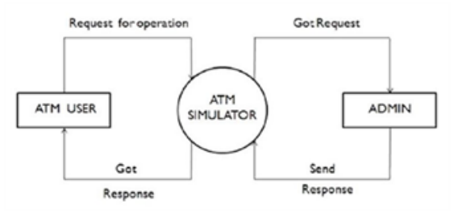

Figure 1.0 *0 level DFD*

* Data Flow Diagram (Level-1): In Automated Teller System project, there are four processes like Pin enter, Checking, Deposit and Withdraw. Database of the project is customer. User enter the pin admin (Administrator) will verify the pin with the help of customer database. If pin is correct, admin allows the user to process the other processes like checking, deposit. Checking process reads the data from database, similarly deposit and withdraws reads as well as writes data in database.

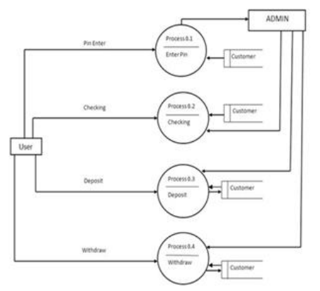

Figure 2.0 *Data flow diagram (Level 1)*

## 2.8 Images from testing the codes

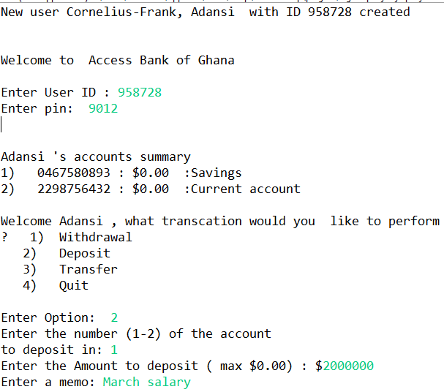

*Figure 3.0 Depositing amount into the savings account*

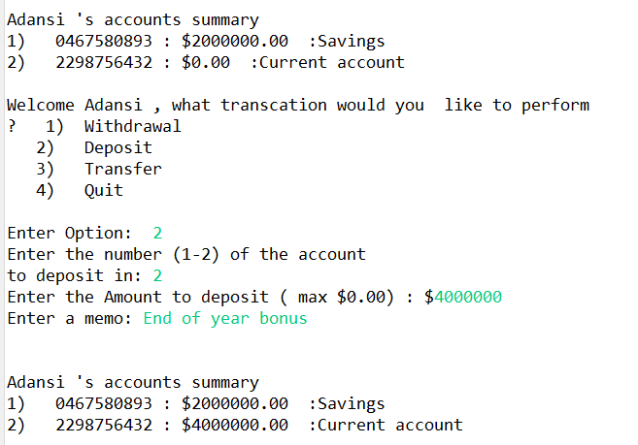

*Figure 4.0 Depositing amount into the current account*

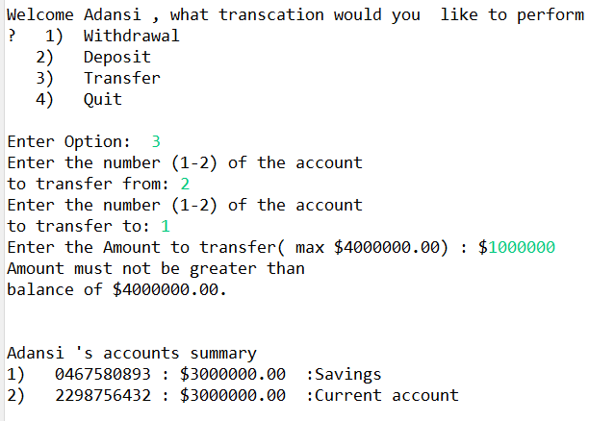

*Figure 5.0 Transfer amount into the savings account from the current account*

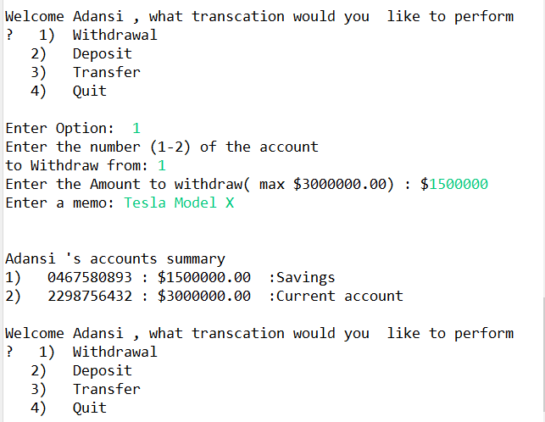

*Figure 6.0 Withdraw amount from the savings account*

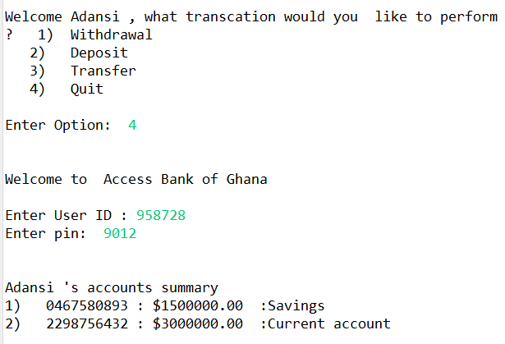

*Figure 3.0 User quit/exit from the options*

# 3.0 CONCLUSION

In 1969, Chemical Bank announced that a new form of banking was being launched. With that, customers were provided with plastic cards designed with a magnetic strip that could be used with a machine built into a wall. Gone were the days of having to stand in line for a teller or not having money on hand after normal banking hours. Almost everyone has heard of and used an ATM system. Interestingly, some of people feel that ATM systems are the best thing to happen in the banking world while other people consider them a curse. The main complaint heard about ATM systems is that while they are convenient, they are expensive to use. However, if we look at it from a banking perspective, business is business. Regardless of what we think of ATM systems, there is no doubt that they have changed the world and the way in which we do things. For example, think how many times we have been out somewhere only to discover we have no cash and we are out of checks, but in the corner, there is an ATM machine. In the blink of an eye, we swipe the card and now have cash on hand. In addition to pulling money out, the ATM machine also makes it convenient to deposit money, transfer money, and check balances. Best of all, to use an ATM machine, we do not have to go to the bank. We will find ATM machines at other banks, grocery stores, shopping malls, along the roadside, Buckingham Palace, airports, in casinos, and even on the South Rim of the Grand Canyon. For this reason, ATM machines are extremely helpful.

# 4.0 REFERENCES

[1]. ATM Forum, Traffic Management Specification Version 4.0, ATM Forum specification, atm–0056-000, April 1996.

[2]. ATM Forum, ATM user-Network Interface Signalling Specification Version 4.0, ATM Forum specification, af–sig– 0061-000, July 1996.

[3]. N.C. Audsley, ―Optimal Priority Assignment and Feasibility of Static Priority Tasks with Arbitrary Start Times‖, Technical Report YCS-164, University of York, 1991.

[4]. U. Black, ATM: Foundations for Broadband Networks, Prentice Hall, 1995.

[5]. G. Blair, J.B. Stefani, Open Distributed Processing and Multimedia, Addison-Wesley, 1997.

[6]. A. Petit-Bianco, ―Java Garbage Collection for Real-Time Systems‖, Dr. Dobbs Journal, October 1998.

[7]. Chorus Systems, ―CHORUS/ClassiX r3 Technical Overview‖, Technical Report CS/TR-96-119.14, October 1997.